YUVA INTERN | LOGISTICS DATA ANALYST

Week 3: Advanced Data Analysis and Visualization
Logistics Delivery Performance Analysis and Predictive Optimization Using Python
Prepared as an educational project report. Dataset and numerical findings in this package are simulated; they are not company operational records.

1. Objective and analytical sample
The analysis explores 2,400 simulated shipment records after basic cleaning. It examines delivery duration, shipping cost, shipping mode, operating region and relationships among numeric variables. All values below are generated for this educational exercise and should not be interpreted as real company performance.

2. Descriptive statistics
Variable | Mean | Median | Std. dev. | Min | Max
Distance_km | 195.81 | 168.0 | 126.04 | 8.0 | 900.0
Shipment_Weight_kg | 7.95 | 6.7 | 5.7 | 0.2 | 55.0
Order_Quantity | 8.06 | 8.0 | 4.36 | 1.0 | 15.0
Actual_Delivery_Days | 3.01 | 2.95 | 0.96 | 0.4 | 6.71
Shipping_Cost_USD | 47.4 | 45.67 | 13.94 | 17.64 | 85.44
Simulated baseline: on-time delivery rate = 55.4%; delay rate = 44.6%; average actual delivery duration = 3.01 days; average shipping cost = $47.40.

3. Visual analysis

Figure 1. Delivery-time distribution
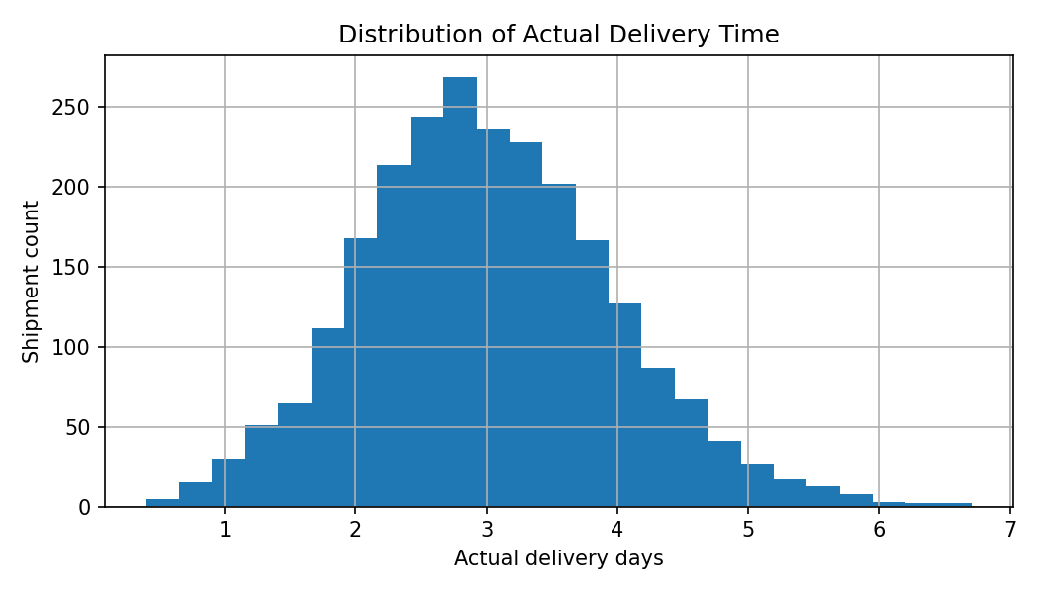
The histogram shows the frequency of delivery durations. A long right tail would indicate a smaller group of shipments taking substantially longer than typical.

Figure 2. Average delivery time by shipping mode
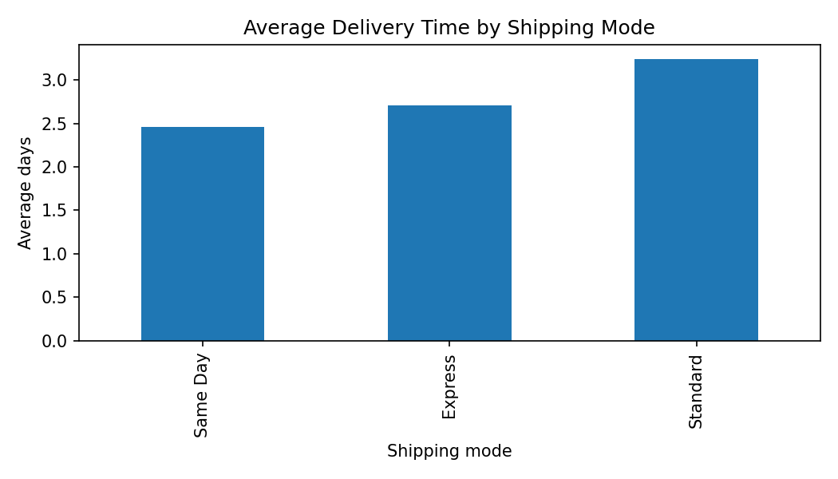
The bar chart compares service modes. It helps assess whether faster service classes are associated with shorter actual transit times and whether service promises are realistic.

Figure 3. Average shipping cost by region
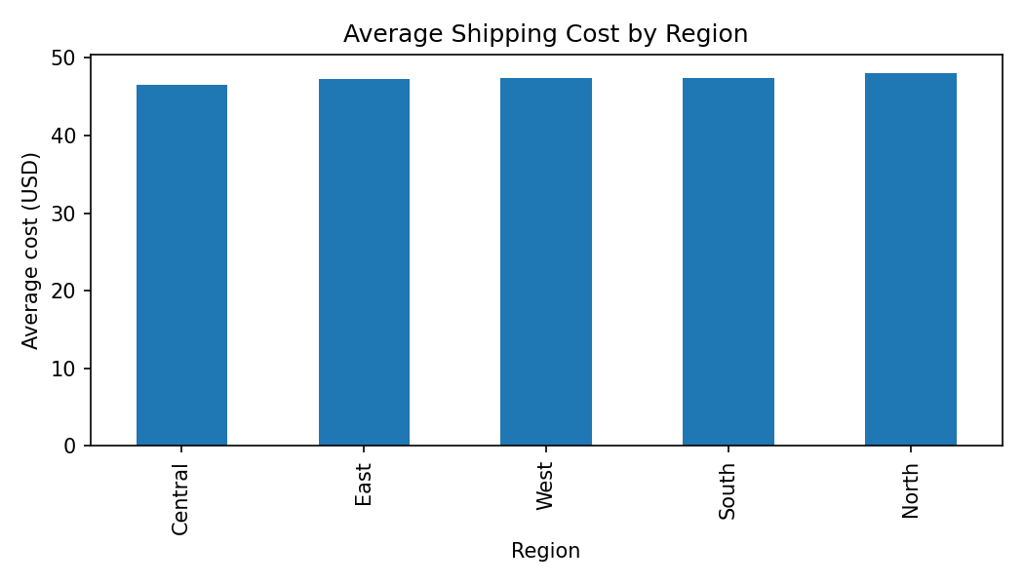
The regional comparison highlights potential cost differences. Managers can investigate route distance, carrier rates, tolls and service mix before making changes.

Figure 4. Correlation matrix
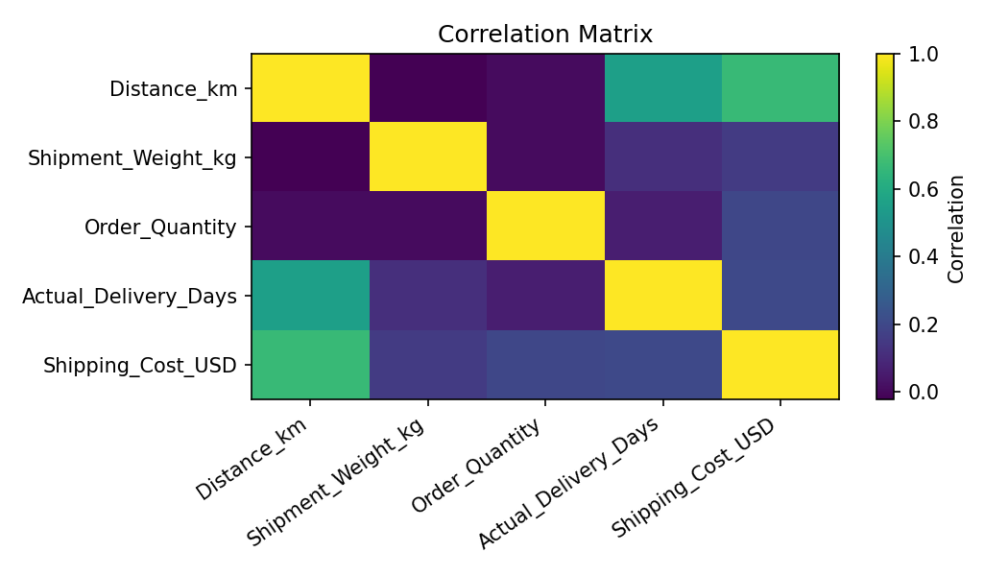
The correlation matrix summarizes pairwise linear relationships among selected numeric variables. Correlation does not prove causation and may be affected by confounding variables.

4. Segment-level KPI analysis
Mode | Shipments | Avg days | On-time rate | Avg cost (USD)
Express | 702 | 2.71 | 19.0% | $54.80
Same Day | 235 | 2.46 | 6.0% | $67.58
Standard | 1463 | 3.24 | 81.0% | $40.61

5. Key insights and interpretation
The figures and segment table provide a baseline for comparing service modes and regions. Delivery duration should be interpreted alongside scheduled duration: a mode can have a lower average transit time but still miss its tighter service promise. Cost comparisons should also be adjusted for distance, weight and service class before concluding that one region is inefficient.
The correlation matrix is useful for identifying candidate predictors, such as distance or shipment weight, but it is not a causal model. Operational investigation is needed to determine whether a relationship is driven by route design, carrier capacity, traffic, weather or a combination.

6. Python code for EDA
import pandas as pd
import matplotlib.pyplot as plt
import seaborn as sns
df = pd.read_csv("logistics_simulated_dataset.csv")
print(df[["Actual_Delivery_Days","Shipping_Cost_USD"]].describe())
print(df.groupby("Shipping_Mode")["Actual_Delivery_Days"].mean())
sns.histplot(df["Actual_Delivery_Days"], bins=25, kde=True)
plt.title("Distribution of Actual Delivery Time")
plt.show()
sns.barplot(data=df, x="Shipping_Mode", y="Actual_Delivery_Days")
plt.title("Average Delivery Time by Shipping Mode")
plt.show()
sns.heatmap(df.select_dtypes("number").corr(), annot=True, cmap="Blues")
plt.show()

7. Recommendations
- Review lanes with consistently high transit times and compare actual duration with the scheduled promise.
- Use a mode-specific service-level dashboard rather than comparing raw average days alone.
- Investigate high-cost regions after controlling for distance, weight and shipping mode.
- Monitor weather and traffic as operational context for dispatch planning.
- Repeat the analysis monthly and track KPI movement against a documented baseline.

8. Limitations
The dataset is synthetic and simplified. It does not contain carrier identity, route geometry, warehouse dwell time, failed delivery attempts, fuel prices or actual timestamp-level events. The analysis is therefore a demonstration of method, not evidence of real operational savings.

